North Tyneside
Family Hub activities
Summer 2023
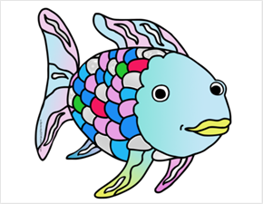
Wellbeing fayre days
Themed Stay and Play days.
Summer fayre days

Week 1
24th July- 28th July
Date | Location and time | Session theme and activities
Monday 24th July | Shiremoor Family Hub Stay and Play  1:00pm-2.30pm | Pirates and Princesses.  Activities including, map making, treasure hunt and telescope crafts.
Tuesday 25th July | Howdon Family Hub Summer Fayre Day  10:00am-2:00pm | Summer Fayre activities including, bracelet making, Tombola, Bouncy castles and more!
Wednesday 26th July | Howdon Family Hub  9:30am-12:00pm | Pirates and Princesses.  Activities including map making, treasure hunt and telescope crafts.
Thursday 27th July | Whitley Bay Customer First Centre Stay and Play  1:30pm-3:00pm | Pirates and Princesses.  Activities including, map making, treasure hunt and telescope crafts
Friday 28th July | Riverside Family Hub  Stay and Play  9:30am-12:00pm | Pirates and Princesses.  Activities including, map making, treasure hunt and telescope crafts
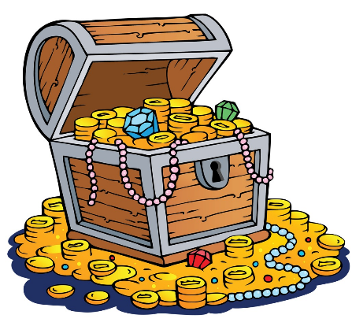
Date | Location and time | Session theme and activities
Monday 31st July | Howdon Family Hub Stay and Play  9:30am-12:00pm | Under the sea themed  activities including, bubble painting and puppet making.
Tuesday 1st August | Howdon Family Hub Wellbeing fayre  10:00am-2:00pm | Wellbeing fayre Day  Activities: Bloom Babies, The Library Bus and Mini Movers.
Wednesday 2nd August | Shiremoor Family Hub Stay and Play  9:30am-12:00pm | Under the sea themed  activities including, bubble painting and puppet making.
Friday 4th August | Riverside Family Hub  Stay and Play  9:30am-12:00pm | Under the sea themed  activities including, bubble painting and puppet making.
Week 2
31st July- 4th August

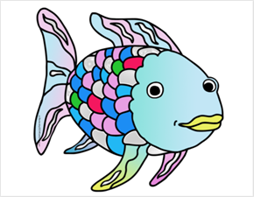

Week 3
7th August- 11th August
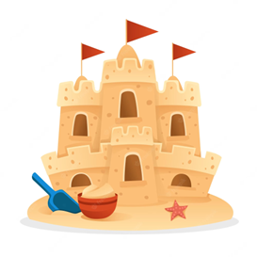

Date | Location and time | Session theme and activities
Monday 7th August | Howdon Family Hub Stay and Play  9:30am-12:00pm | Beach theme  activities including, exploring rock pools and sea crafts.
Tuesday 8th August | Riverside Family Hub Stay and Play  9:30am-12:00pm | Beach theme  activities including, exploring rock pools and sea crafts
Wednesday 9th August | Whitley Bay Customer First Centre  1:00pm-2:30pm | Beach theme  activities including, exploring rock pools and sea crafts.
Thursday 10th August | Shiremoor Summer Fayre Day  10:00am-2:00pm | Summer Fayre Day  activities including, bracelet making, Tombola, Bouncy castles and more!

Week 4
14th August- 18th August

Date | Location and time | Session theme and activities
Monday 14th August | Shiremoor Family Hub Stay and Play  1:00pm-2:30pm | Walking in the jungle themed activities including, den building and designing jungle masks.
Tuesday 15th August | Howdon Family Hub Stay and Play  9:30am-12:00pm | Walking in the jungle themed activities including den building and designing jungle masks
Wednesday 16th August | Whitley Bay Customer First Centre  1:30pm-3:00pm | Walking in the jungle themed activities including, den building and designing jungle masks.
Thursday 17th August | Shiremoor Family Hub Wellbeing fayre  10:00am-2:00pm | Wellbeing fayre day.  Activities including, Bloom Babies, The Library Bus and Mini Movers
Friday 18th August | Riverside Family Hub Stay and Play  9:30am-12:00pm | Walking in the jungle themed  activities including, den building and designing jungle masks.

Week 5
21st August- 25th August
Date | Location and time | Session theme and activities
Monday 21st August | Howdon Family Hub Stay and Play  9:30am-12:00pm | Story themed week  activities including, retelling the Gruffalo story
Tuesday 22nd August | Shiremoor Family Hub Stay and Play  9:30am-12:00pm | Story themed week activities including, retelling the Gruffalo story
Wednesday 23rd August | Riverside Family Hub Summer Fayre Day  10:00am-2:00pm | Summer Fayre Day  activities including, bracelet making, Tombola, Bouncy castles and more!
Thursday 24th August | Whitley Bay Customer First Centre Stay and Play  1:30pm-3:00pm | Story themed week  activities including, retelling the Gruffalo story
Friday 25th August | Riverside Family Hub  Stay and Play  9:30am-12:00pm | Story themed week  activities including, retelling the Gruffalo story
Date | Location and time | Session theme and activities
Tuesday 29th August | Shiremoor Family Hub Stay and Play  9:30am-12:00pm | Natural resources week.  Activities including, Tie dying materials (Bring own materials) and making own nature mobiles.
Wednesday 30th August | Riverside Family Hub Wellbeing fayre day  10:00am- 2:00pm | Wellbeing fayre day.  Activities including, Bloom Babies, The Library Bus and Mini Movers
Thursday 31st August | Whitley Bay Customer First Centre Stay and Play  1:30pm-3:00pm | Natural resources week.  Activities including, making own nature mobiles and lots of sensory trays to explore!
Friday 1st September | Howdon Family Hub  Stay and Play  9:30am-12:00pm | Natural resources week.  Activities including, Tie dying materials (Bring own materials) and making own nature mobiles.
Week 6
28th August- 1st September
