**Parent information booklet**

**Early Years Parent Information Booklet**

**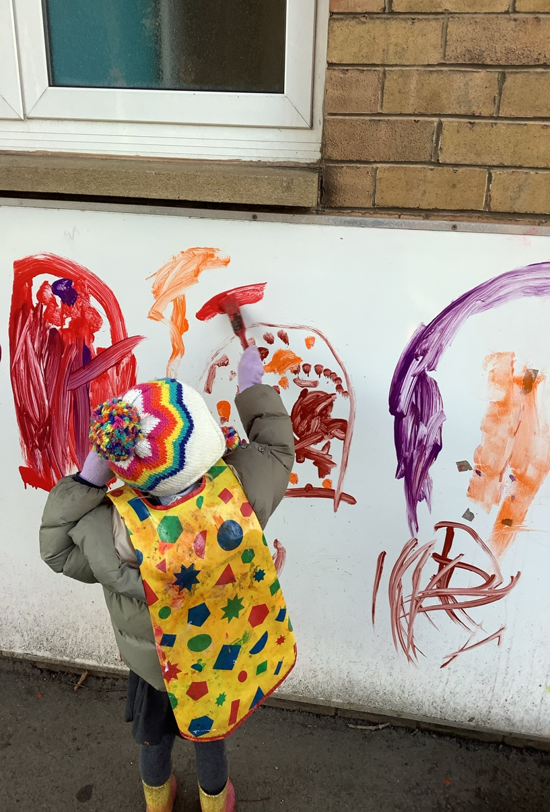**

**Welcome to Nursery!**

|  |
| --- |
| **Our staff**  Class Teacher- Mrs Dormand  Teaching Assistants- Mrs Burton and Mrs Murphy  PPA Teacher- Miss Sanderson (Tuesday morning)  Headteacher & SENDCO – Mrs Bradford  Deputy Headteacher – Mrs Pearce  Assistant Headteacher- Mrs Wake  **Our Classroom**  We provide a caring and nurturing environment which enables every child to flourish and to 'let their light shine'. Our team is committed to your child's learning, wellbeing and happiness.  We are located in our own building to the back of the school.  \\ccpsserver01\Shared\Staff\Mrs Cull\September 2021\IMG_1367.JPG  **Timings of the school day**  Morning session 8:45- 11:45am  Afternoon session 12:15- 3:15pm  We offer both free **15- and 30-hour** places for those that are eligible.  From the age of 3, **all** children are England are entitled to 15 hours of free childcare per week.  At Christ Church we have a flexible approach to fit around the needs of individual families, which means that you can choose how you would like to claim your free hours.  Please refer to the Department of Education’s website and search ’30 hours free Children’ to check eligibility at <https://www.gov.uk/30-hours-free-childcare>  If you require further provision you can pay to stay at Nursery for the additional time. Please speak to a member of staff if you would like further information.  **Clothing**  We do have a school uniform:   * grey skirt/trousers * white polo shirt/white blouse/white shirt * navy blue cardigan, jumper or sweatshirt with or without the school logo * sensible black school shoes- no trainers * blue-check summer dresses   School Uniform can be purchased from Emblematic, which is in Benton (Near Asda).  **Please mark all clothing with your child's name**.  The first day  We recognise that the first steps in education are important for every child, and we feel honoured to be a part of your child's journey. We will work with parents to ensure that this transition is as smooth as possible.  Useful information  Please bring a water bottle to school every day.  We go outside in almost all weathers. Please ensure that your child has a pair of wellies, a raincoat, hat, scarf and gloves. All children require a spare set of clothing and underwear in a bag.  P.E is every Tuesday. Children should wear comfortable clothing such as navy jogging bottoms/ leggings and a plain T shirt.  Forest School is a Friday afternoon. Nursery, Reception and Year 1 children merge to provide a range of activities including Campfire, Art and obstacle course type challenges. The children will have the opportunity to visit each activity across the half term.  Toys and personal belongings must be left at home.  Milk and snack  Children receive a piece of fruit at snack time each day.  If your child would like milk please register at [www.coolmilk.com](http://www.google.com/url?q=http%3A%2F%2Fwww.coolmilk.com%2F&sa=D&sntz=1&usg=AFQjCNEl5uCqX-qbbT4bUmdlTCb5aU_UbA). Milk is free until your child reaches the age of 5.  Our curriculum  The foundation stage curriculum is organised into 7 areas of learning:   * Personal, Social and Emotional Development * Communication and Language * Literacy * Maths * Understanding of the World * Expressive Arts and Design * Physical development   Our curriculum is child-centred where learning is personalised to the needs and interests of the children. We provide meaningful experiences which engage children and support them to be creative, curious and to develop a love of learning.  We love learning through purposeful play and exploring ideas together. Your child will also participate in daily phonics sessions to develop their speaking and listening skills further.  On our school website, we have a class page where there will be an overview of what we are learning each half term and our curriculum goals.  Illness  If your child is unwell, please ring the school office to let us know. Do not send them back until they are recovered.  SEND  We are an inclusive school, and we aim for all children to reach their full potential. Our provision is carefully planned to that child with additional needs have access to high quality teaching.  Our Local Offer outlines the way which children with special educational needs and or disabilities are supported at our school. This can be found on our website under the SEND section and our Early Years page.  If you have any questions, please contact Mrs Dormand (Class Teacher) or Mrs Bradford (Special Educational Needs Co-Ordinator)  Safeguarding  Our classroom and the gate to our garden area is locked throughout the session to ensure the safety of our children. If you arrive late to school, please report to the school office.  We have many policies and procedures to ensure the school operates efficient and effectively. You can access these on our school website.  **Mrs Bradford** – Designated Safeguarding and Child Protection Lead  **Mrs Pearce** – Deputy Designated Safeguard and Child Protection Lead  **Mrs Bell, Mrs Wake and Mr Needham** are also fully trained Designated Safeguarding Leads  We hope that this booklet has been useful. If you have any queries, please do not hesitate to contact us on [0191 2570323](tel:0191%202570323) (School office telephone number).  We look forward to working with you to provide the best education possible for your children.  Thank you for your support.  The Nursery Team |
|  |
|  |